In-Class Exercise: Calculated Fields

**FILE to use: Telecommunications.twbx**

Your task: recreate the dashboard depicted below **exactly**:

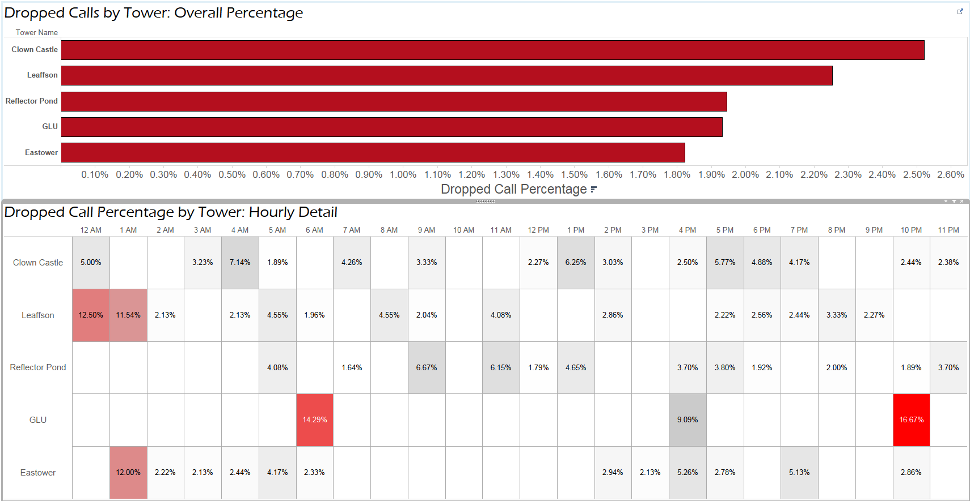

*Important notes:*

* *“Dropped Call Percentage” is the percentage of “Attempted” calls that are “Dropped” – total dropped call / total attempted calls*
* *In the bottom viz, there is only a label in cells that have a positive percentage of dropped calls*